MBUYA PARENTS’ SCHOOL

P.1 LITERACY B TERM II LESSON NOTES

THEME 1 WEATHER

SUB THEME: 1 Types and elements of weather.

Weather is the state of the atmosphere at a given time

Or

Weather is the daily condition of a place at a given

time.

Elements of weather

Elements of weather are things which make weather to

Change.

These are:

sunshine cloud cover rainfall

wind humidity air pressure temperature

Activity

1. What do we call the state of the atmosphere at a given time?
2. Name any three elements of weather.
3. Which element of weather makes us wet?
4. Identify the element of weather that dries our clothes.

Types of weather/ weather conditions.

rainy cloudy

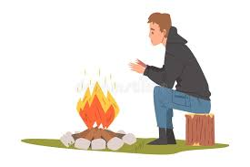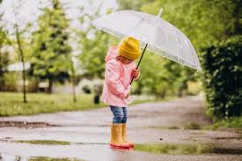

sunny windy

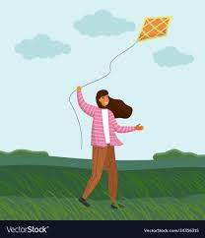

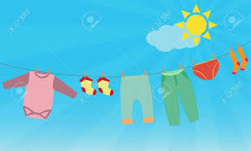

Activity

1. Name any two weather conditions.
2. Draw these types of weather.

Rainy windy

1. Match types to elements of weather.

sunny wind

rainy cloud cover

cloudy sunshine

windy rainfall

The sun

The sun is the main natural source of light.

Uses of the sun

1. The sun gives us light.
2. The sun dries our clothes.
3. The sun gives us solar energy.
4. The sun dries our seeds.
5. The sun gives us warmth.
6. The sun gives us vitamin D

Activity

1. What is the main natural source of light?
2. Give any two uses of the sun.
3. Draw a sunny weather
4. Which type of weather makes us sweat?
5. Apart from the sun, name other two sources of light.

Dangers of too much sunshine.

1. Too much sunshine dries our plants.

2. Too much sunshine spoils our eyes.

3. Too much sunshine dries water bodies.

4. Too much sunshine kills animals.

Activity

1. How is the sun dangerous to people?

2. Name these water bodies.

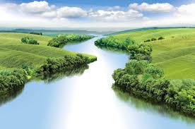………………..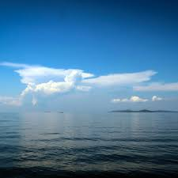…………

3What causes drought?

Things we use to manage a sunny weather.

umbrella vest sandals

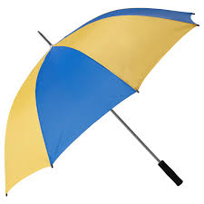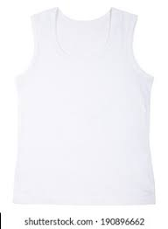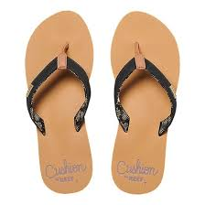

Sunglasses

Activity

Sunglasses hat

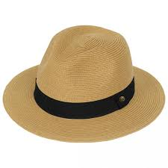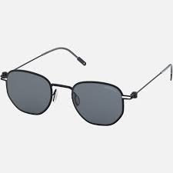

1. Name any three things we use to manage a sunny weather.

2. Identify the type of weather below

………………………………



3. Write any two elements of weather.

Ways of managing a sunny weather.

1. By wearing a hat.

2. By putting on sun glasses.

3. By carrying an umbrella.

4. By putting on sandals.

5. By sitting under shade.

**Activity**

1. How can you manage a sunny weather?

2. Name these things we use to manage a sunny weather.



……

. ……………………..…………

Rain

Rain is the main natural source of water.

Uses of rain.

Nnnnnnnnnnnn 1. Rain helps plants to grow well.

2. Rain adds water to water bodies.

3. Rain makes soil soft for digging.

4. Rain gives us water.

**Activity**

1. Rain gives us water. give any two uses of water.

2. What is the main natural source of water?

3. Identify any two sources of water.

4. Draw a rainy weather.

Things we use to manage a rainy weather.

Umbrella gumboots sweater

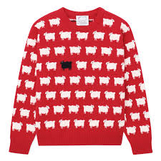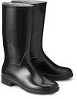

Banana leaf rain coat scarf

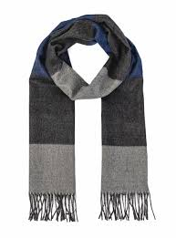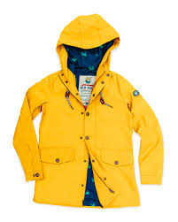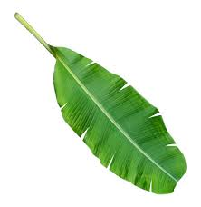

Jacket

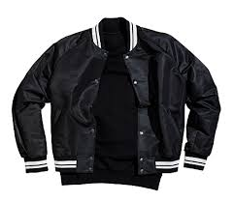

**Activity**

1. Which clouds give us rain?
2. Mention any three things we use to manage a rainy weather.
3. Read and draw

gumboots sweater

Ways of managing a rainy weather.

1. By carrying an umbrella.
2. By wearing gumboots.
3. By wearing a sweater.
4. By putting on a rain coat.
5. By wearing a jacket.
6. By carrying a banana leaf.

**Activity**

1. How can you manage a rainy weather?
2. Draw these things we use to manage a rainy weather.

rain coat gumboots

Dangers of floods.

1. Floods kill people and animals.
2. Floods destroy houses.

3. Floods destroy plants.

4. Floods block roads.

5. Floods spread diseases.

**Activity**

1. What causes floods?
2. How are floods dangerous to people?
3. Circle the things we use to manage a rainy weather.

vest sweater sun glasses gumboots

Wind

Wind is moving air.

Uses of wind.

1. Wind dries our clothes.
2. Wind helps kites to fly.
3. Wind sails boats.
4. For winnowing.
5. Wind takes away the bad smell.

**Activity**

1. What is wind?
2. Identify any three uses of wind.
3. Draw a windy weather
4. Name the activity below.

……………………………

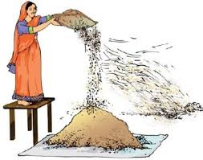

Dangers of wind.

1. Wind destroys houses.
2. Wind destroys crops.
3. Wind spreads diseases
4. Wind breaks bridges.

**Activity**

1. Mention any two dangers of wind.
2. Draw a windy weather.

Sub theme 3: Activities for different seasons.

Types of seasons

Dry season wet season

Activities done in the wet season.

Digging planting crops / sowing

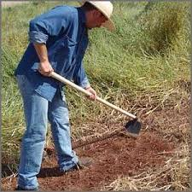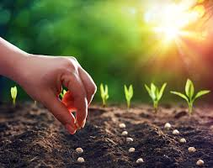

Pruning harvesting water

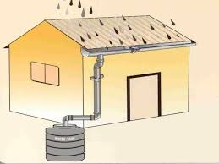

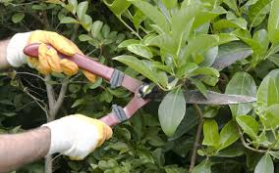

weeding

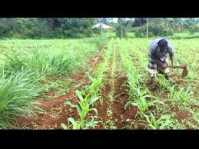

**Note:**

**Weeding** is the removal of un wanted plants from the garden.

**Pruning** is the removal of excess branches from the plant.

**Activity**

1. Name the two seasons you know.
2. In which season do farmers plant crops?
3. Which garden tool is used for weeding?
4. Write any two activities done in the wet season.

Activities done in the dry season.

Harvesting crops drying seeds

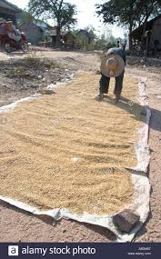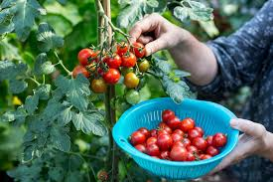

Watering crops clearing land

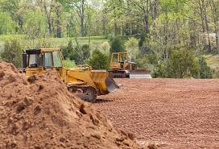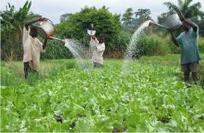

**Activity**

1. Draw the activities done in the dry season.

Harvesting crops watering crops

1. In which season do farmers dry crops?
2. Name any two tools used to harvest crops.

Tools used to harvest water.

Jerry can bucket

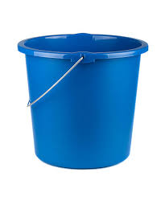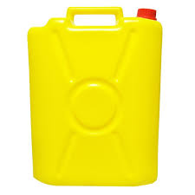

Basin saucepan

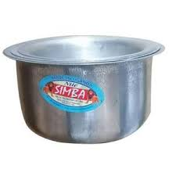

Water tank water drum

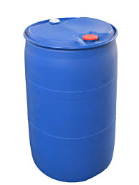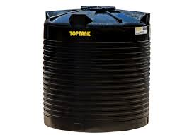

Pot



**Activity**

1. Mention any three tools used to harvest water.

2. In which season do farmers harvest water?

3. Name the tools used to harvest water.

Garden tools / farm tools.

hoe basket spade

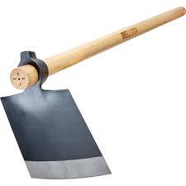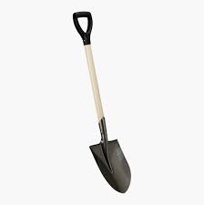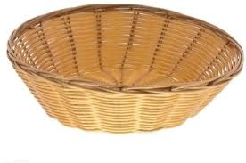

rake slasher garden fork

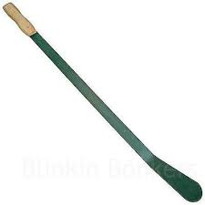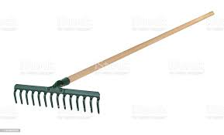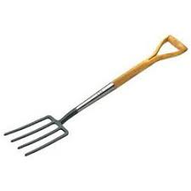

wheelbarrow knife watering can

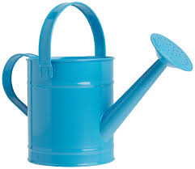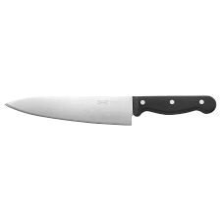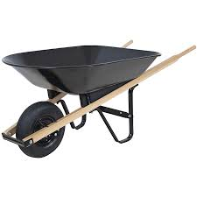

sickle axe panga

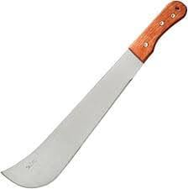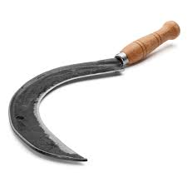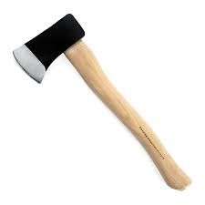

**Activity**

1. Name any four garden tools

2. Draw these garden tools.

sickle axe

Uses of garden tools.

1. Watering can: for watering crop

2. Hoe: for digging.

3. Slasher: for slashing.

4. Panga: for cutting small trees.

5. Wheelbarrow: for carrying manure.

6. Rake: for collecting rubbish.

7. Basket: for carrying harvested food.

8. Axe: for cutting big trees.

How to care for garden tools.

By cleaning them after use.

By keeping them in a cool dry place.

**Activity**

1. How is a hoe useful to a farmer?
2. Give the use of these garden tools.

……………………………..



…………………………………..



1. Which garden tool is used for carrying manure?

**THEME 2:** **LIVING TOGETHER**

**Sub theme 1:** **The family**

A family

A family is a group of people related by blood,

Marriage or adoption.

**Types of families.**

Nuclear family extended family

**Activity**

1. What do we call a group of people related by

blood, marriage or adoption?

1. How are children related to their parents?
2. Underline types of families.

Dog family, nuclear family, book family, extended

Nuclear family

A nuclear family is a family where we find parents and their own children.

**Members in a nuclear family.**

Father mother

Sister brother

**Activity**

1. In which type of family do we find parents and their own children.
2. Identify any two members in the nuclear family.

3. Draw the members in a nuclear family.

sister father

An extended family

An extended family is a family where we find

Parents , children and other relatives.

Relatives include

Niece cousin brother aunt grand mother

Nephew cousin sister uncle grand father

Activity

1. In which type of family do we find relatives?
2. Underline relatives only.

father , aunt , sister , grandmother

1. Draw these members in an extended family.

grandfather aunt

Relationship among family members.

1. The father to my mother or mother is my grandfather.
2. The mother to my father or mother is my grandmother.
3. The sister to my mother or father is my aunt.
4. The brother to my mother or father is my uncle.

Activity

1. Match correctly

Father to my mother uncle

Mother to my father aunt

Sister to my mother grandmother

Brother to my father grandfather

Family relationship

1. The son to my mother or father is my brother.
2. The daughter to my mother or father is my sister.
3. The daughter to my sister or brother is my niece.
4. The son to my sister or brother is my nephew.
5. Children of my uncle or aunt are my cousins.

**Activity**

1. What do you call the son to your sister?

2. Children of my uncle are my ……………………

3. Complete the family tree.

mother

father

……..

Ways of living together at home.

1. By sharing.

2. By helping one another.

3. By playing together

.4. By working together.

5. By respecting elders.

**Activity**

1. How do children live together at home?
2. Name any two games children play at home.
3. How can you show respect to elders?

Ways of living together at school.

1. By playing together.
2. By sharing.
3. By obeying school rules.
4. By respecting one another.
5. By caring for one another.

6. By helping one another.

**Things children do together at school.**

Learning singing

Playing praying

**Activity**

1. Name any two things you can share with a friend.
2. Name any two play objects at school.
3. How do children live together at school?

School rules

These are the things we must follow or obey at school.

**Examples of school rules.**

1. Come to school early.
2. Wear the school uniform.
3. Respect teachers and prefects.
4. Do all the exercises given.
5. Do not fight or abuse others.
6. Do not escape from school.
7. Respond to the bell.

**Activity**

1. Name any two school rules and regulations.
2. Why do we need rules at school?
3. Why do pupils wear the school uniform?

Ways of living together in the community.

1. By obeying community rules.
2. By doing community work together.
3. By praying for one another.
4. By obeying elders.
5. By sharing with neighbours.

**Activity**

1. How do people live together in the community?
2. Write any two examples of communal work.

Ceremonies people do together in the community

Wedding baptism burial

Introduction confirmation funeral rites

Importance of working together.

1. It promotes unity.
2. It brings happiness.
3. It creates friendship.
4. It saves time.

**Activity**

1. Identify any two ceremonies people do together in the community.
2. How can you show love and care for one another?
3. Give any two importance of working together.

**THE END**